ToDo Mini – Quick guide

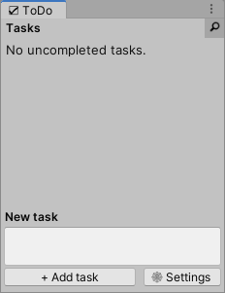
Opening the window
Press Ctrl+T to open ToDo mini. (You can also open it from “Window > ToDo mini”.)
Note: if the window is already opened, press Ctrl+T to focus on the “New task” field to quickly add a new task, without having to click on the field.

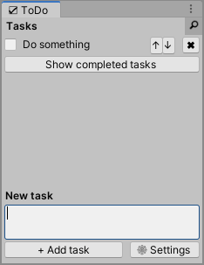
Creating tasks
Click inside of the new task field, type your task, then press Enter to add it. (You can also create it by clicking the “Add task” button.)

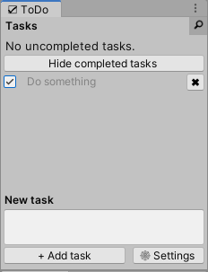
Marking tasks as completed
Click the task’s checkbox to mark a task as completed.
You can show completed tasks by pressing the “Show completed tasks” button.

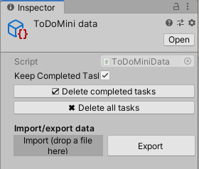
Settings
Click the “Settings” button on the ToDo mini window. This takes you to the object that holds ToDo mini’s data.
Here:
- Choose whether to keep or not to keep completed tasks (if you won’t keep them, completing a task will destroy it).
- ✖ Delete completed tasks, or all tasks.
- ↑ Export the current tasks (uncompleted and completed).
- ↓ Import previously exported tasks. To do this, drag and drop the .json file into the “Import” drop area. The imported tasks will be added to the current tasks list.

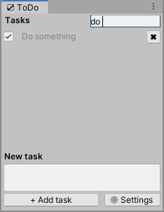
Search
Click the magnifying glass icon () to open the sear bar. Then type the task that you want to find.

Other features
You can edit a task by clicking on it and typing.
You can move the current tasks up and down using the arrow buttons on the end of the task line.
You can delete a task by pressing the arrow next to it.

